
A&J Cases  11121 Hindry Avenue  Los Angeles, CA 90045 | (800) 537-4000 toll free  (310) 216-2170 voice  (310) 216-2694 fax
www.ajcases.com

General Product catalog of 11 pages as of September 1999. Features and specifications subject to change. Contact us or visit our website for the most current information and updates.

DI CASES
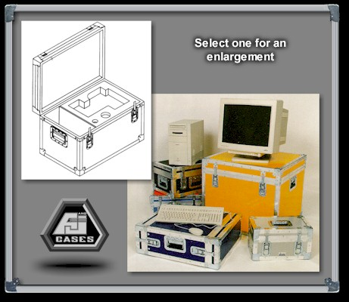
Advanced packaging Design and Protection:
A&J DI cases designed and manufactured to meet or exceed the Air Transportation Association specification 300, Category 1 requirements. A&J Cases are the most reliable, reusable cases available in the industry.
The Importance of Reliable Protection:
Because of ever changing technology and rapid advancements in manufacturing, better packaging is required to dramatically reduce damage in shipping. A&J Cases has the expertise to offer you the best packaging available in the marketplace today for shipping your delicate equipment.
DI Case Technical Information:
Construction Features | Options | Industry Applications
- 1/4", 3/8" or 1/2" solid core plywood  - Fiberglass, ABS plastic, aluminum exterior laminate available in a variety of colors  - Aluminum edging  - Aluminum tongue and groove valance  - Recessed handles (size permitting)  - Recessed catches (size permitting)  - 2" full length steel piano hinge  - Steel stacking corners  - Steel split rivets | - Foam interiors  - Key lock  - Large or small twist catch  - Large twist catch with key lock  - Engraved nameplate  - Padlocked clips  - Caster assembly  - Removable caster assembly  - Retractable handle with recessed casters (size limitations)  - Wood or metal skids  - Water proof document holders  - Access doors  - Roll in ramps  - Rubber feet  - Stencil/silk screen  - Gasket seal valance | - Computer  - Audio/Visual  - Broadcast  - Athletic  - Medical  - Trade show  - Aerospace  - Auto Racing  - Airline  - Movie  - Lighting  - Test Equipment  - Video

DI-2 CASES
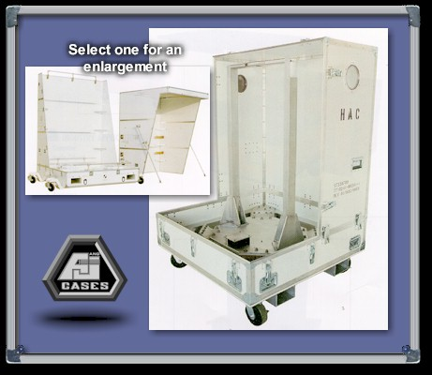
Large scale containers designed and manufactured to give the maximum protection for the large and more delicate equipment.
DI-2 containers can be constructed from composite materials or plylam, depending on the application, with many different isolation systems.
A&J offers consulting and design services for special projects.
DI-2 Case Technical Information:
Construction Features | Industry Applications
- Solid core plylam  - Composite materials  - Aluminum edging  - Aluminum valance  - Recessed hardware  - Corner protection  - Tie downs  - Lifting rings  - Humidity indicator  - Pressure relief valve  - Nitrogen purge valve  - Isolation systems | - Aerospace  - Airline  - Trade Show  - Test Equipment

DI Lite CASES
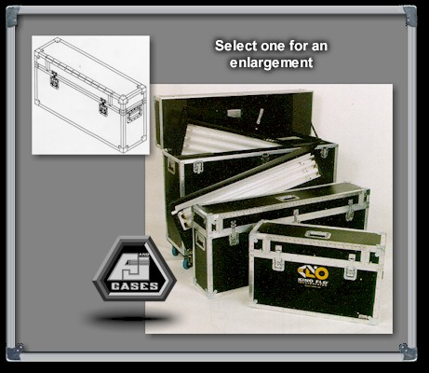
Heavyweight Protection:
A&J DI Lite Case designed and manufactured to provide heavyweight protection in a lightweight case and still meet the Air Transportation Association specification 300, Category 1 requirements. A&J Cases are the most reliable reusable cases available in the case industry.
A&J DI Lite Case is an average of 30% lighter in weight than the standard DI Case. Manufactured of 500# MSF high density corrugated polyethylene, DI Lite offers the same protection while providing reduced shipping expense.
DI Lite Case Technical Information:
Construction Features | Options | Industry Applications
- 500# MSF corrugated high density polyethylene  - Available in blue, black, green, olive drab, gray, orange, red , yellow and white  - Aluminum edging  - Aluminum tongue and groove valance  - Recessed aluminum handles  (size permitting)  - Recessed catches (size permitting)  - 2" full length aluminum piano hinge  - Steel stacking corners | - Foam interiors  - Key lock  - Large or small twist catch  - Large twist catch with key lock  - Padlock clips  - Retractable handle with recessed casters  (size limitations)  - Water proof document holders  - Engraved nameplate | - Computer  - Audio/Visual  - Broadcast  - Medical  - Athletic  - Aerospace  - Airline  - Movie  - Lighting  - Trade Show  - Video  - Test Equipment

DI RACK SHELL CASES
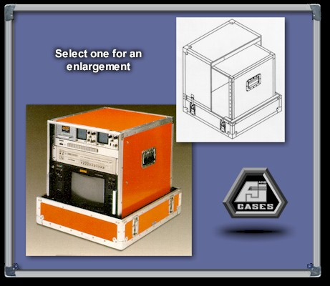
A lightweight rackmount frame, which conforms to the Electronic Industry Association (EIA) 19" width standard. Completely removable from the 1" polyethylene foam lined outer case, featuring a pull-over lid with valances spanning catches. The rackmount frame features recessed handles, aluminum trim, along with rubber feet for stability. Standard models 4U to 27U spaces with rack depth of 20".
DI Rack Shell Case Technical Information:
Construction Features | Options | Industry Applications
- Removable lids front and back  - 1/4", 3/8', 1/2" solid core plywood  - Fiberglass or ABS plastic laminates available in a variety of colors  - Aluminum edging  - Aluminum tongue and groove valance  - Recessed handles  - Large twist catches  - Recessed catches  - Front EIA channel pre-taped 10/32  - Steel split rivets | - Rear EIA  - Caster assembly  - Removable caster assembly  - Stacking features  - Locking catches  - Key locks  - Rackmount associated accessories, drawers, trays, sliding shelves, etc.  - Stencil/silk screen  - Variable rack depths  (16, 18, 22, 24 inch)  - Gasket seal valance  - Engraved nameplate | - Computer  - Trade Show  - Movie  - Broadcast  - Aerospace  - Test Equipment  - Audio/Visual  - Sound  - Video

Panel Openings
Space | Heightht |  | Space | Height
4U | 7” |  | 16U | 28”
5U | 8 ¾” |  | 17U | 29 ¾”
6U | 10 ½” |  | 18U | 31 ½”
7U | 12 ¼” |  | 19U | 33 ¼”
8U | 14” |  | 20U | 35”
9U | 15 ¾” |  | 21U | 36 ¾”
10U | 17 ½” |  | 22U | 38 ½”
11U | 19 ¼” |  | 23U | 40 ¼”
12U | 21” |  | 24U | 42”
13U | 22 ¾” |  | 25U | 43 ¾”
14U | 24 ½” |  | 26U | 45 ½”
15U | 26 ¼” |  | 27U | 47 ¼”
Spaces greater than 27U on request

DI SHOCK MOUNT CASE
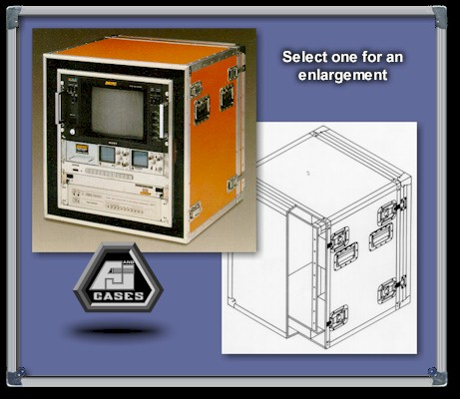
A floating case within a case design. The interior case, which conforms to the Electronic Industry Association (EIA) 19" width standard, is separated from the outer case by a series of polyethylene shock absorbers that provide maximum protection for audio, video, or computer components. Standard models 4U to 27U spaces with rack depth of 20".
DI Shock Mount Case Technical Information:
Construction Features | Options | Industry Applications
- Removable lids front and back  - 1/4", 3/8', 1/2" solid core plywood  - Fiberglass or ABS plastic laminates available in a variety of colors  - Aluminum edging  - Aluminum tongue and groove valance  - Recessed handles  - Large twist catches  - Recessed catches  - Front EIA channel pre-taped 10/32  - Steel split rivets | - Rear EIA  - Caster assembly  - Removable caster assembly  - Stacking features  - Locking catches  - Key locks  - Rackmount associated accessories, drawers, trays, sliding shelves, etc.  - Stencil/silk screen  - Variable rack depths  (16, 18, 22, 24 inch)  - Gasket seal valance  - Engraved nameplate | - Computer  - Trade Show  - Movie  - Broadcast  - Aerospace  - Test Equipment  - Audio/Visual  - Sound  - Video

Panel Openings
Space | Heightht |  | Space | Height
4U | 7” |  | 16U | 28”
5U | 8 ¾” |  | 17U | 29 ¾”
6U | 10 ½” |  | 18U | 31 ½”
7U | 12 ¼” |  | 19U | 33 ¼”
8U | 14” |  | 20U | 35”
9U | 15 ¾” |  | 21U | 36 ¾”
10U | 17 ½” |  | 22U | 38 ½”
11U | 19 ¼” |  | 23U | 40 ¼”
12U | 21” |  | 24U | 42”
13U | 22 ¾” |  | 25U | 43 ¾”
14U | 24 ½” |  | 26U | 45 ½”
15U | 26 ¼” |  | 27U | 47 ¼”
Spaces greater than 27U on request

DI STANDARD RACKMOUNT CASE
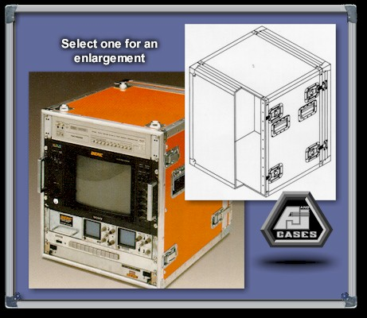
This front and rear access rackmount case conforms to the Electronic Industry Association (EIA) 19" width standard. Highly portable and will accommodate any combination of equipment and accessories. Standard models 4U to 27U with rack depth of 20".
DI Standard Rackmount Case Technical Information:
Construction Features | Options | Industry Applications
- Removable lids front and back  - 1/4", 3/8", or 1/2" solid core plywood  - Fiberglass or ABS plastic laminates available in a variety of colors  - Aluminum edging  - Aluminum tongue and groove valance  - Recessed handles  - Large twist catches  - Recessed catches  - Front EIA channel pre-taped 10/32  - Steel split rivets | - Rear EIA  - Caster assembly  - Removable caster assembly  - Stacking features  - Locking catches  - Key locks  - Rackmount associated accessories, drawers, trays, sliding shelves, etc.  - Stencil/silk screen  - Variable rack depths  (16, 18, 22, 24 inch)  - Gasket seal valance  - Engraved nameplate | - Computer  - Trade Show  - Movie  - Broadcast  - Aerospace  - Test Equipment  - Audio/Visual  - Sound  - Video

Panel Openings
Space | Heightht |  | Space | Height
4U | 7” |  | 16U | 28”
5U | 8 ¾” |  | 17U | 29 ¾”
6U | 10 ½” |  | 18U | 31 ½”
7U | 12 ¼” |  | 19U | 33 ¼”
8U | 14” |  | 20U | 35”
9U | 15 ¾” |  | 21U | 36 ¾”
10U | 17 ½” |  | 22U | 38 ½”
11U | 19 ¼” |  | 23U | 40 ¼”
12U | 21” |  | 24U | 42”
13U | 22 ¾” |  | 25U | 43 ¾”
14U | 24 ½” |  | 26U | 45 ½”
15U | 26 ¼” |  | 27U | 47 ¼”
Spaces greater than 27U on request
The XP Expandable
The XP Expandable Shipping Container System is a lightweight, weather resistant, Roto Molded Plastic Container. Designed to expand in length, to stack, and to have forklift access. Interior space can be customized or divided with modular partitions.
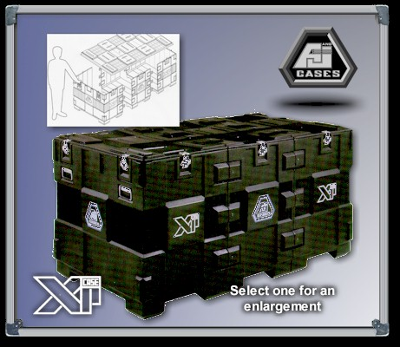
The XP Expandable Case Technical Information:
Construction Features | Options
- Modular design  - Roto Molded Polyethylene  - Molded Weather Resistant Closures  - Recessed Handles and Catches  - Stackable  - Standard color black | - Expandable Container Modules  - Removable Dividers  - Custom Interior  - Removable Casters  - Key Locks  - Custom Logos  - Optional Colors (minimum Run)

Model | Interior Length | Interior Width | Interior Height
XP-0  XP-1  XP-2  XP-Module | 49”  73”  97”  24” | 38”  38”  38”  38” | 31”  31”  31”  31”
Optional 5” caster set (4 pieces)

POWER LIFT CASE
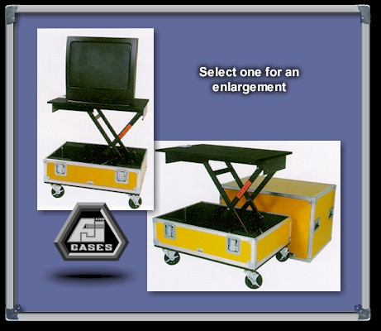
A&J Lift case, designed and manufactured to add ease of handling for heavyweight monitors, projectors, and other computer equipment.
These Lift cases use lift mechanisms that provide a smooth and quiet lift, while offering protection for your valuable equipment. The mechanism can be adjusted to accommodate a total payload ranging from 100 to 350 pounds, with a vertical travel distance of 0 to 42 inches, depending upon the lift mechanism required.
Powerlift Case Technical Information:
Construction Features | Options | Industry Applications
- 3/8" or 1/2" solid core plywood  - Fiberglass, ABS plastic, or aluminum exterior laminate available in a variety of colors  - Aluminum tongue and groove valance  - Recessed handles  - Recessed catches  - Steel corners  - Caster Assembly  - Gas lift range 100-200 lbs. | - Gas lift range 200-400 lbs.  - Foam interiors  - Key lock  - Engraved nameplate  - Removable casters asmb  - Access doors  - Stencil/ Silk screen  - Gasket seal valance | - Computer  - Audio/ Visual  - Broadcast  - Medical  - Trade Show  - Aerospace  - Test Equipment  - Video

RMC CASES
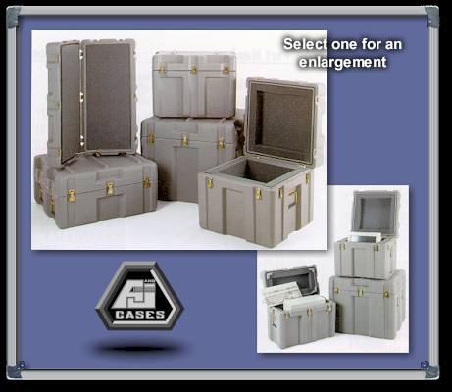
RMC Roto molded cases represent the ultimate in total packaging capability. They offer a reliable alternative to the standard and custom cases manufactured by A&J Cases.
Designed for style as well as durability, these cases can withstand considerable abuse, even in extremely harsh environments.
RMC Cases Technical Information:
Construction Features | Options | Industry Applications
- Rotationally molded polyethylene plastic  - Integrally molded tongue and groove closure  - Color impregnated  - Recessive hardware  - Spring loaded handles  - Cam action, positive locking catches  - Meets ATA 300 Category 1, and applicable portions of MIL-T-STD-108  - Stock color-gray (other colors allow 2 weeks)  - Interlocking ribs for easy stacking | - Foam interiors  - Relief valve  - Humidity indicator  - Stainless steel hardware  - Air/ water-tight removable lid  - Air/ water tight hinged lid  - Removable casters | - Electronic  - Computer  - Medical  - Aerospace  - Audio/ Visual  - Military Applications  - Test Equipment  - Video  - Trade Show

STAR PAK
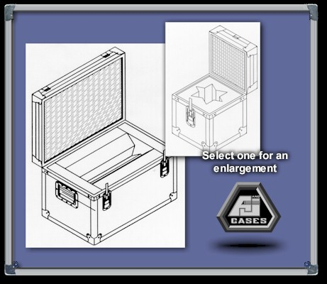
A&J Star Pak Cases are designed for delicate items with irregular configurations. The Star Pak Series containers incorporate all the standard features and are built to meet the Air Transportation Association specification 300, Category 1.
The specifically designed polyurethane ester foam inserts provide maximum protection and flexibility.
This flexibility enables you to select a DI Reusable Shipping Container that does not require a custom insert and still protects your product from damage due to vibration or sudden shock during shipping.
Star Pak Technical Information:
Star Pak Specifications

A&J Mfg. Part No. | Minimum Cavity | Maximum Cavity | Container size id.
 |  |  | Length Width Height
40-009 | 2 ½ x 4 | 3 x 4 ½ | 8 8 8
40-010 | 2 ½ x 6 | 3 x 6 ½ | 8 8 10
40-011 | 2 ½ x 8 | 3 x 8 ½ | 8 8 12
40-012 | 3 ½ x 4 | 4 x 4 ½ | 8 8 8
40-013 | 3 ½ x 6 | 4 x 6 ½ | 8 8 10
40-014 | 3 ½ x 8 | 4 x 8 ½ | 8 8 12
40-015 | 4 ½ x 4 | 5 x 4 ½ | 10 10 8
40-016 | 4 ½ x 6 | 5 x 6 ½ | 10 10 10
40-017 | 4 ½ x 8 | 5 x 8 ½ | 10 10 12
40-018 | 3 x 10 | 3 ½ x 10 | 14 8 8
40-019 | 3 x 11 | 3 ½ x 11 | 14 8 8
40-020 | 4 x 10 | 4 ½ x 10 | 14 10 10
40-021 | 4 x 11 | 4 ½ x 11 | 14 10 10

THE UTILIZER
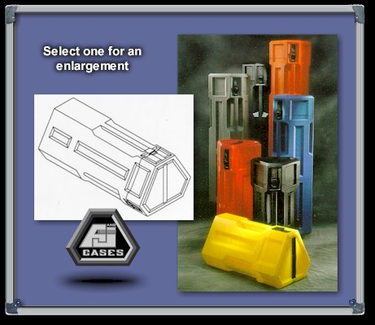
The only tripod case designed by the leading professionals in the movie industry.
The Utilizer is the finest, most thought out and thoroughly designed shipping and storage container in the industry.
The Utilizer Technical Information:
Construction Features | Options
- Roto molded high-density crosslink polyethylene  - Unique triangular design prevents rolling  - Three handles for easy handling in any position  - Telescoping lid with adjustable web strap  - Fully recessed quick release buckle. | - Custom logos and sizes available  - Optional colors available (minimum quantity required)  - Seven sizes available in stock  - Standard color black

MODEL | Dia. | Int Ht | LIST
AII-2128 | 9” | 24”-28” | 210.00
AII-2140 | 9” | 37”-41” | 225.00
AII-2144 | 9” | 41”-45” | 230.00
AII-2152 | 9” | 49”-53” | 235.00
AII-2156 | 9” | 53”-57” | 240.00
AII-2030 | 11” | 26”-30” | 225.00
AII-2044 | 11” | 42”-46” | 245.00

